**Advanced Mathematics**

**Lab 2**

Yu-Hao Chiang 3443130

**Exercise 1 – A little bit of div and curl**

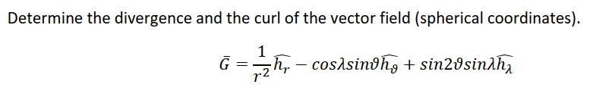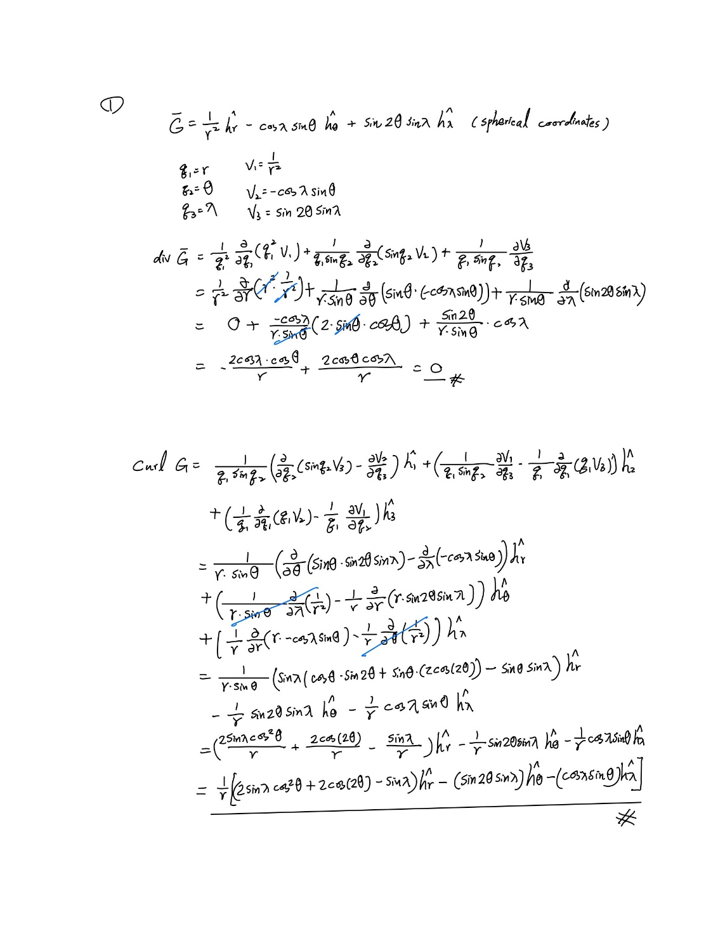

**Exercise 2 – Gradient search**

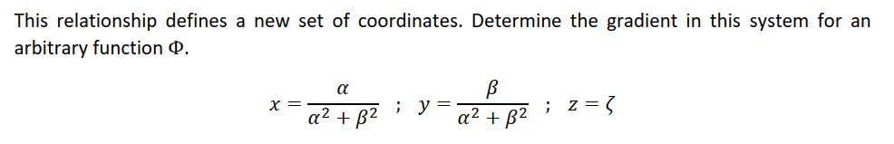

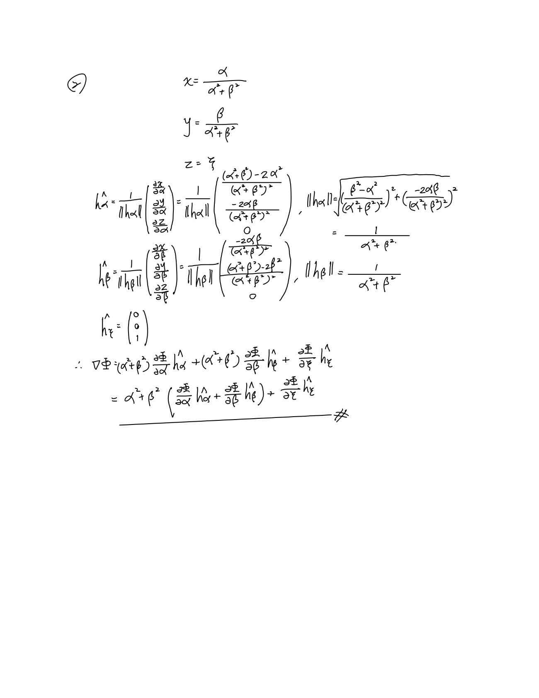

**Exercise 3 – Cylinder coordinate**

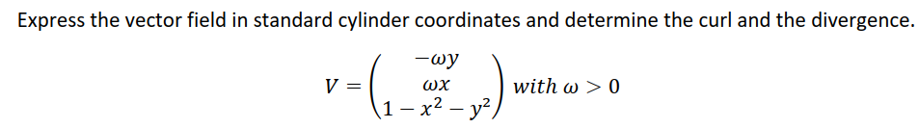

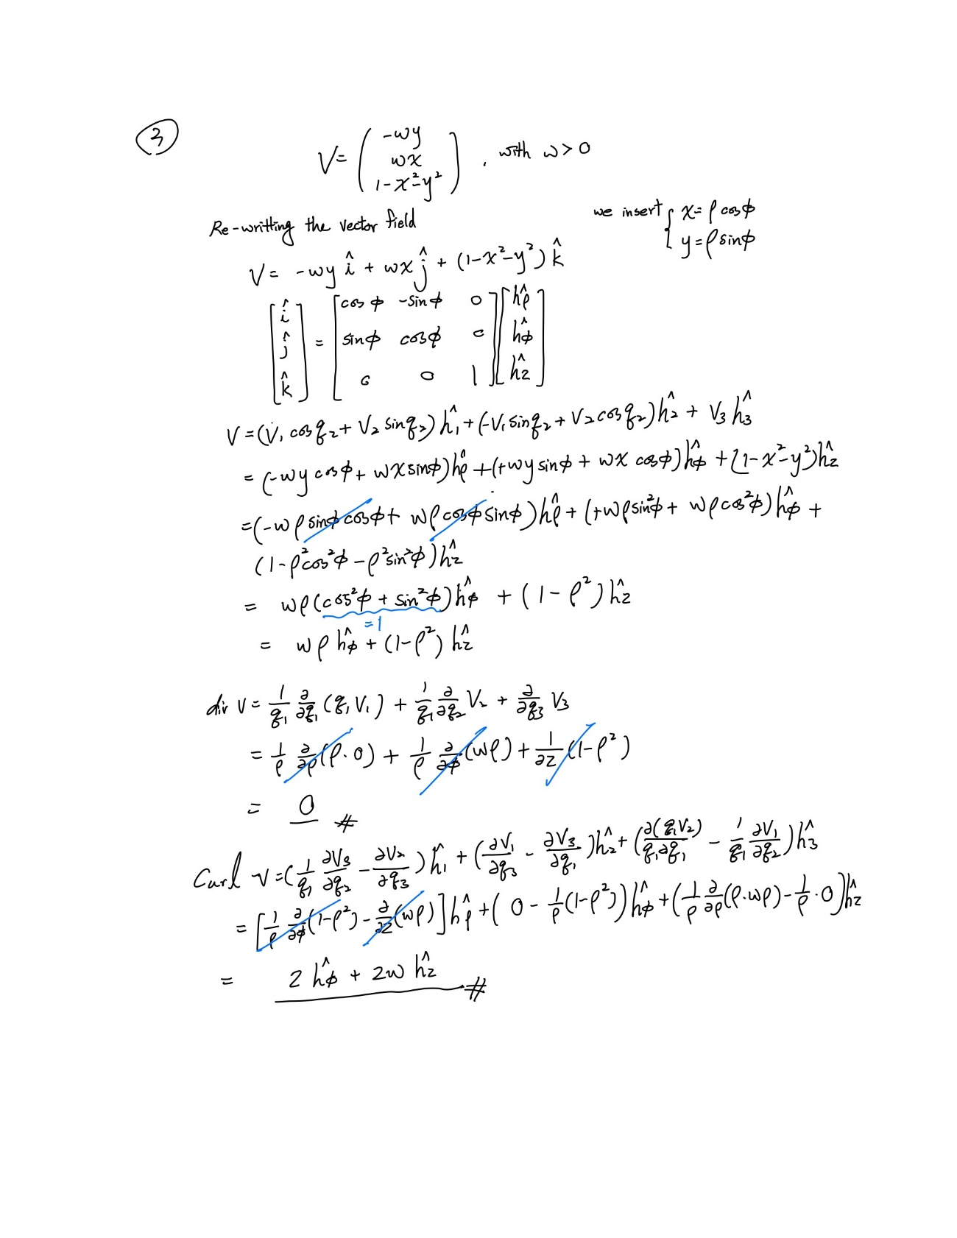

**Exercise 4 – Matlab (AIS_Icesheet_ice, AIUB_CHAMP01S_geoid, weathermodel_winds)**

**AIS_Icesheet_ice:**

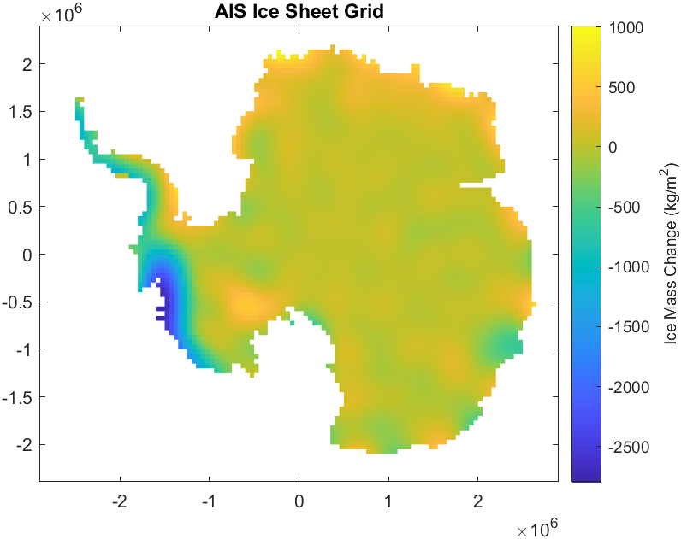

Figure 1 AIS Ice Sheet Grid

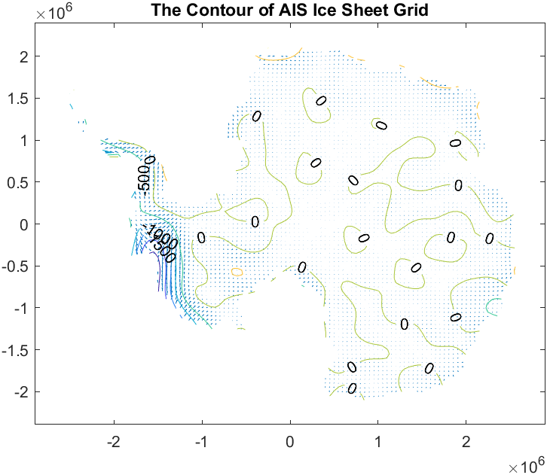

Figure 2 The contour of AIS Ice Sheet Grid

Based on figure 3, we can see that most of the area are showing zero of contour. Because a scalar field is single valued. That means that if you go round in a circle, or any loop, large or small, you end up at the same value that you started at. The curl of the gradient is the integral of the gradient round an infinitesimal loop which is the difference in value between the beginning of the path and the end of the path. In a scalar field there can be no difference, so the curl of the gradient is zero.

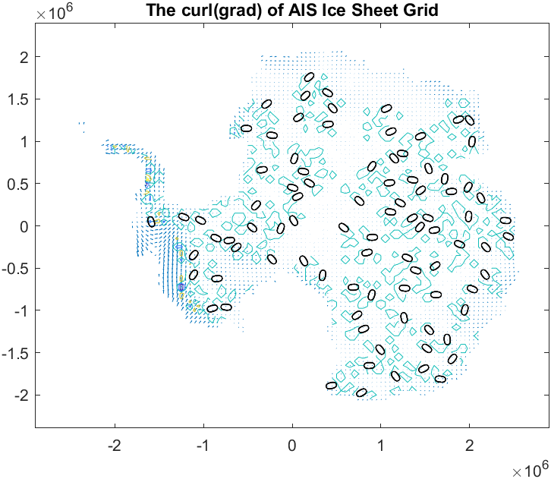

Figure 3 the curl(grad) = 0 of AIS Ice Sheet Grid

**AIUB_CHAMP01S_geoid:**

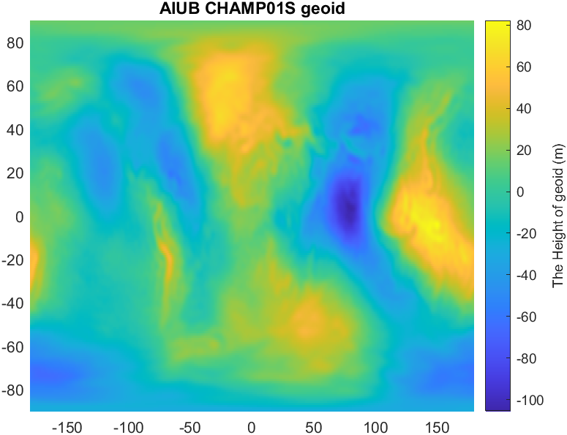

Figure 4 AIUB CHAMP01S geoid

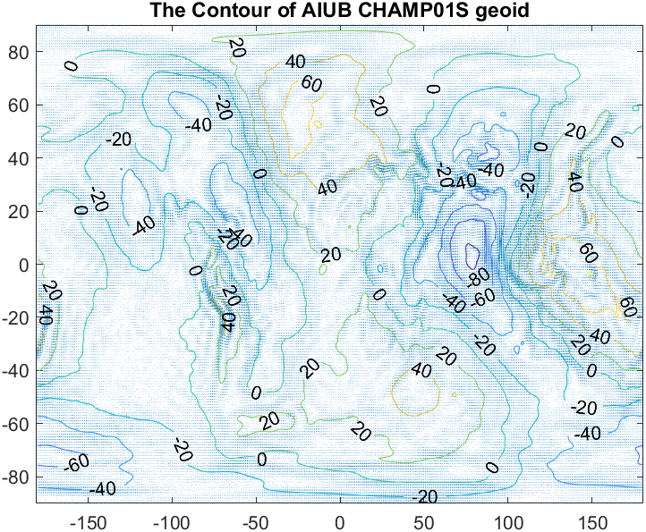

Figure 5 The Contour of AIUB CHAMP01S geoid

The physical interpretation involves the understanding of rotation and convergence. At any point some physical quantity that exhibits the rotation, at that point it can never converge or diverge.

For a scalar field which varies in space, its variation is direction dependent as it may vary differently in different directions of the space. The peak variation (or maximum rate change) is a vector represented by the gradient. Curl of gradient is zero means the rotation of the maximum variation of scalar field at any point in space is zero.

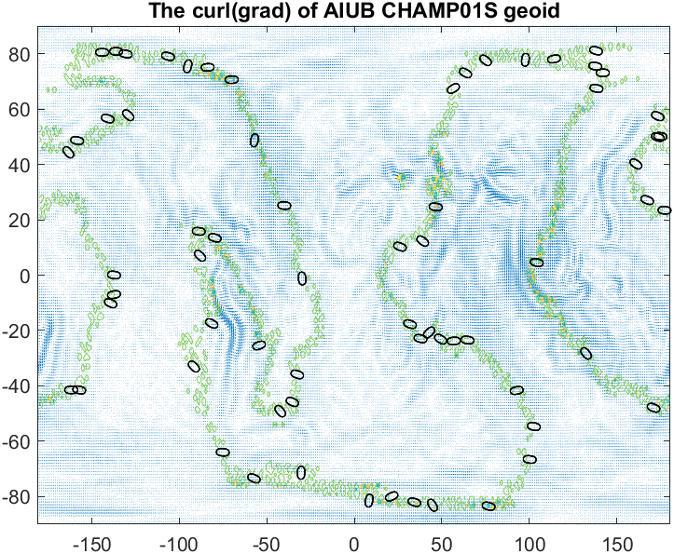

Figure 6 The curl(grad) = 0 of AIUB CHAMP01S geoid

**weathermodel_winds:**

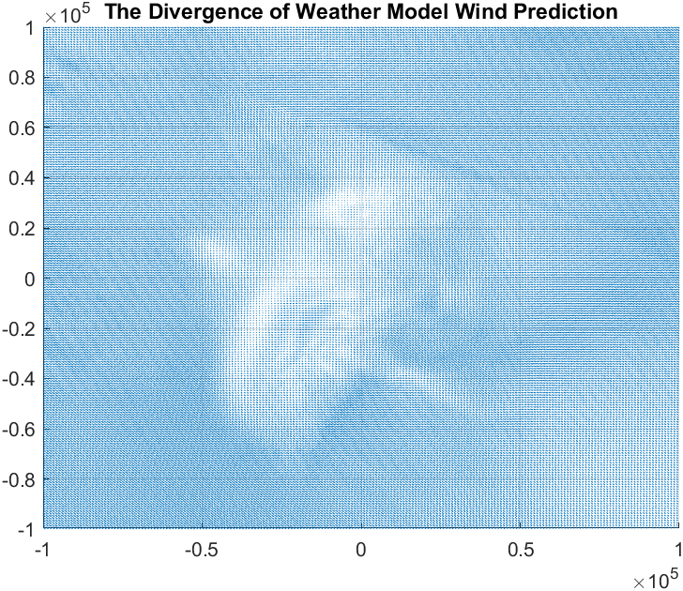

Figure 7 The Divergence of Wind quiver

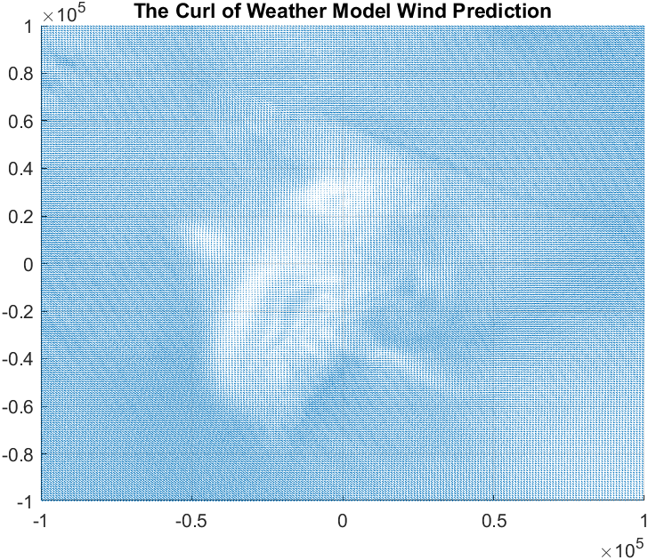

Figure 8 The Curl of Wind quiver

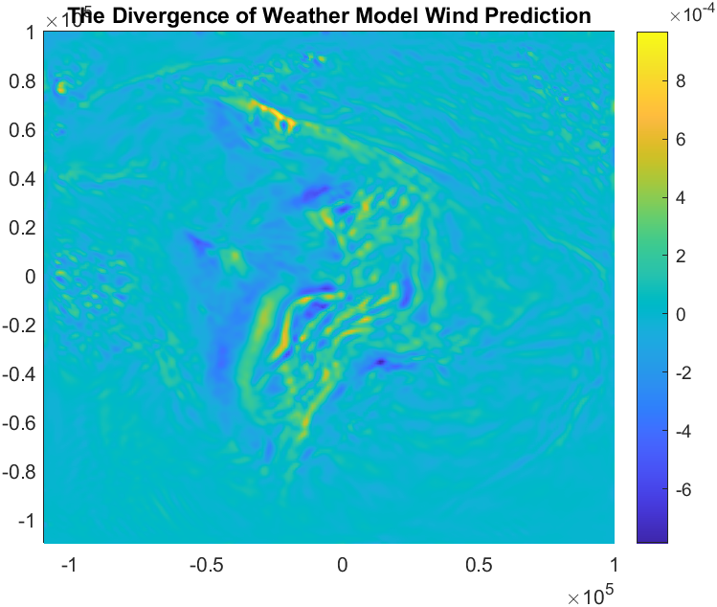

Figure 9 The Divergence of Weather Model Wind Prediction

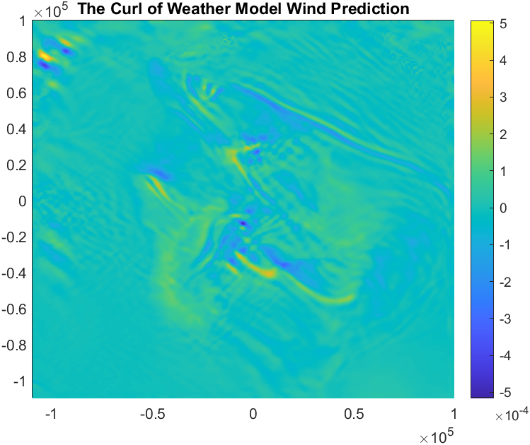

Figure 10 the curl of Weather Model Wind Prediction

The curl of a vector field measures the tendency for the vector field to swirl around. The vector field represents the velocity vectors of winds. If the vector field swirls around, it will tend to spin. The amount of the spin will depend on how we orient. Thus, we should expect the curl to be vector valued.

The divergence of a vector field is often illustrated using the example of the velocity field of a fluid. A moving fluid has a velocity, a speed and direction, at each point which can be represented by a vector, so the velocity of the fluid forms a vector field. If a fluid is heated, it will expand. This will cause a net motion of fluid particles outward in all directions. Any closed surface in the fluid will enclose which is expanding, so there will be an outward flux of fluid through the surface. So, the velocity field will have positive divergence everywhere. Similarly, if the fluid is cooled, it will contract. There will be more room for fluid particles in any volume, so the external pressure of the fluid will cause a net flow of fluid volume inward through any closed surface. Therefore, the velocity field has negative divergence everywhere. In contrast in an unheated fluid with a constant density, the fluid may be moving, but the volume rate of fluid flowing into any closed surface must equal the volume rate flowing out, so the net flux of fluid through any closed surface is zero. Thus, the fluid velocity has zero divergence everywhere.

Last but equally important, the curl of wind has no swirling tendency at all (figure 8). Therefore, we would expect div(curl) = 0.

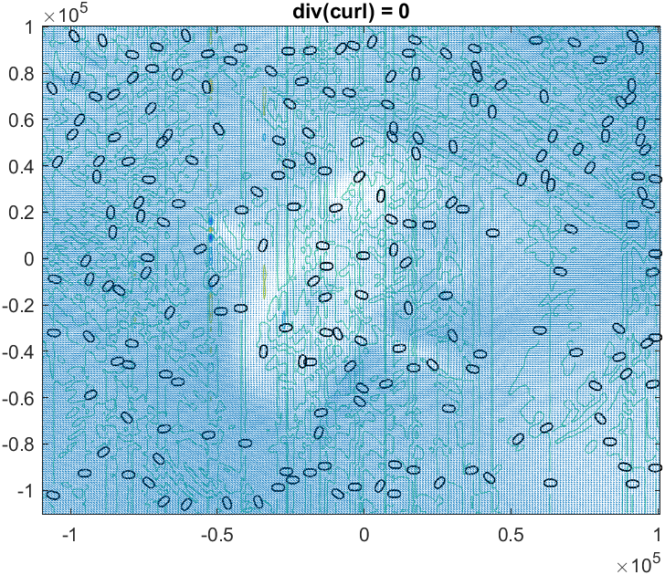

Figure 11 The div(curl) = 0 of Weather Model Wind Prediction